Section 9

* Now we will add functionality to leave meeting using leave meeting button
* 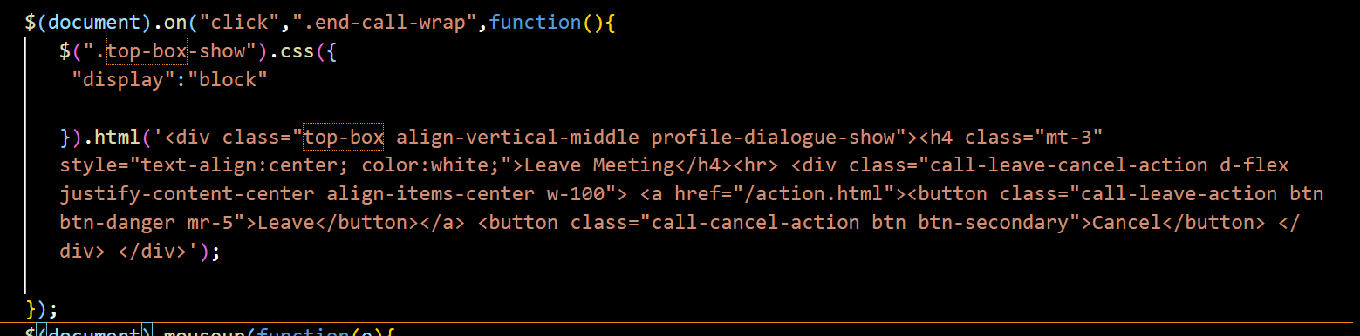

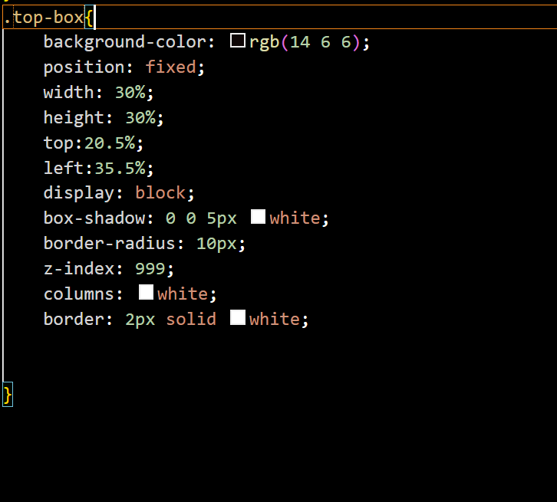

* Now after this if we press on cancel we should stay on same pade also if we click on outside the page then also we should stay on the same page
* 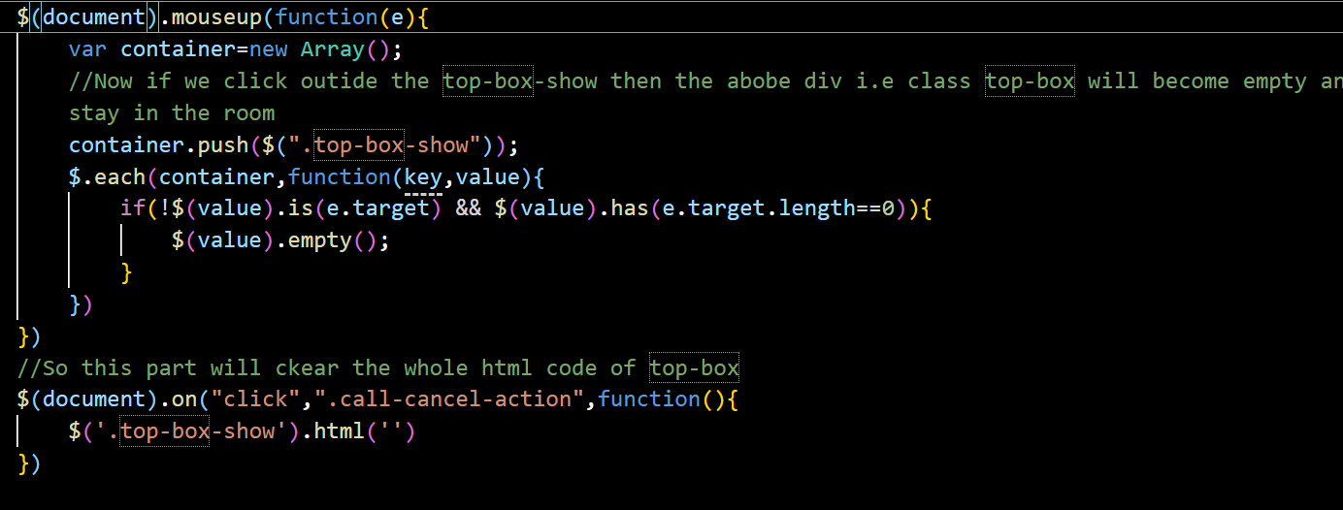

Part2: Meeting Details

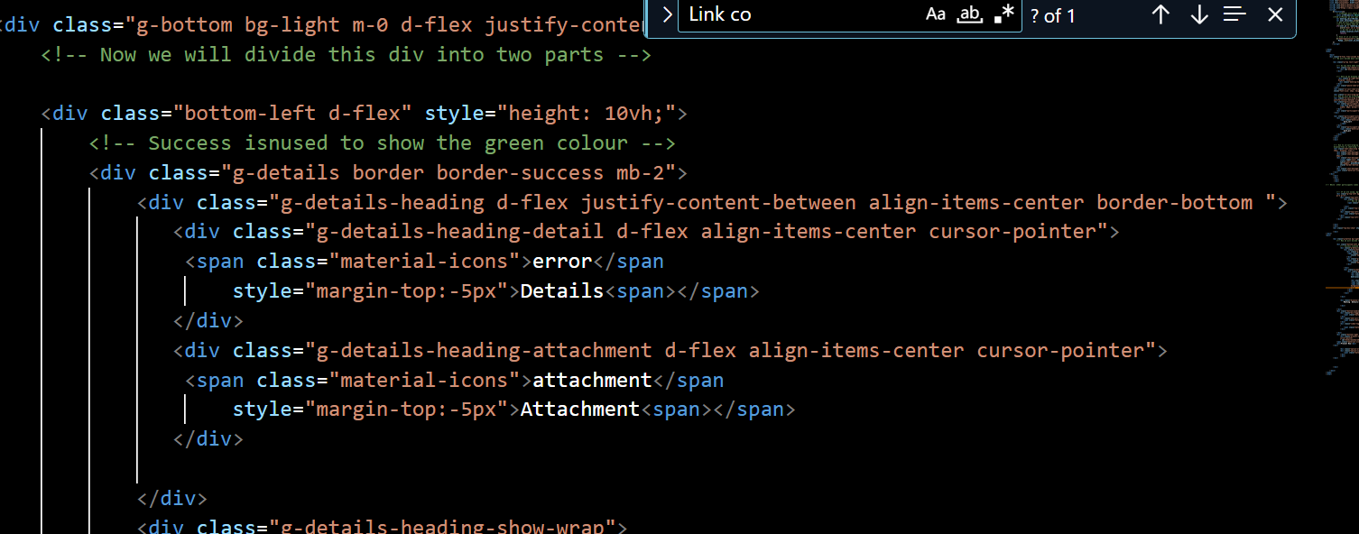

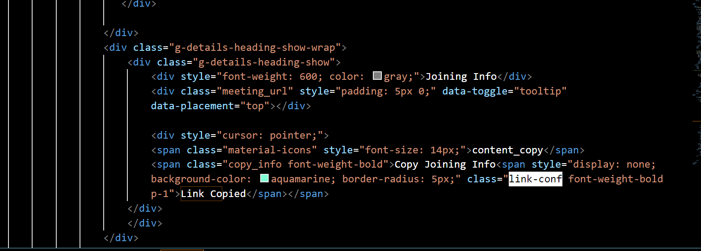

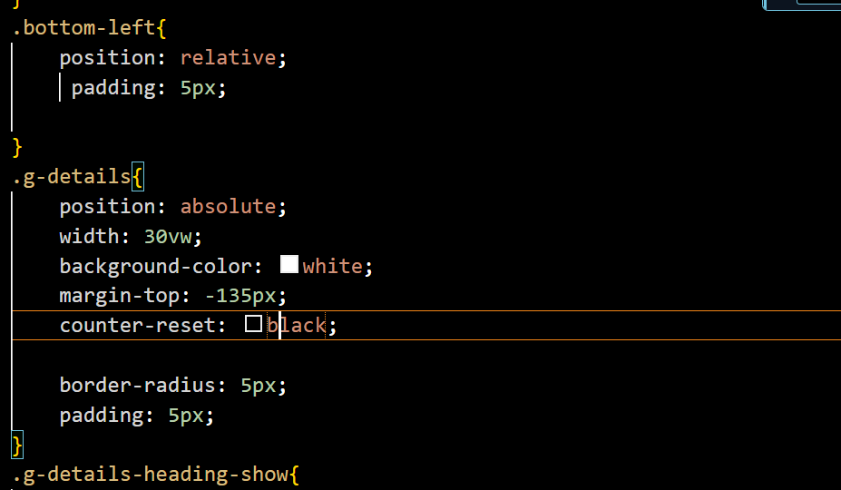

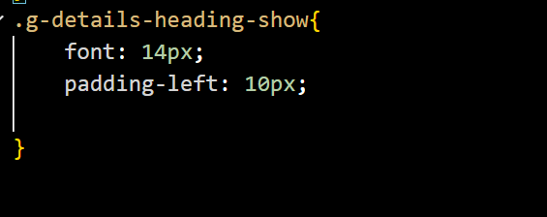

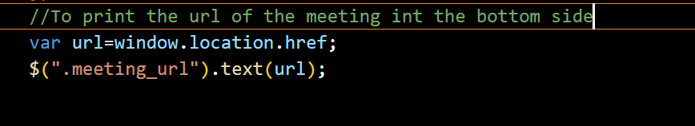

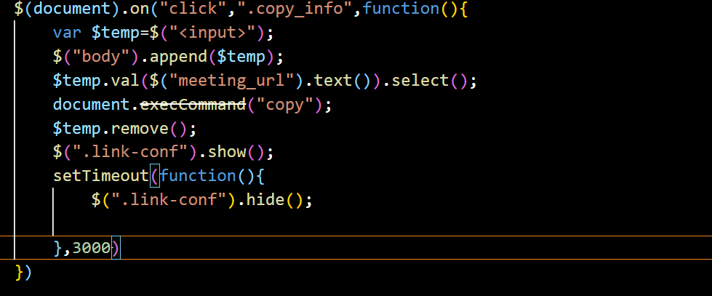

* PART 3: Request Full Screen
* Now if someone double clicks on the video then it should be converted to double screen
* 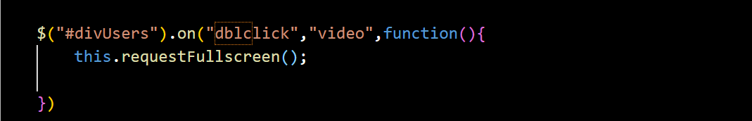
* PART 4:
* In this we will be writing to code to switch details to attachment
* 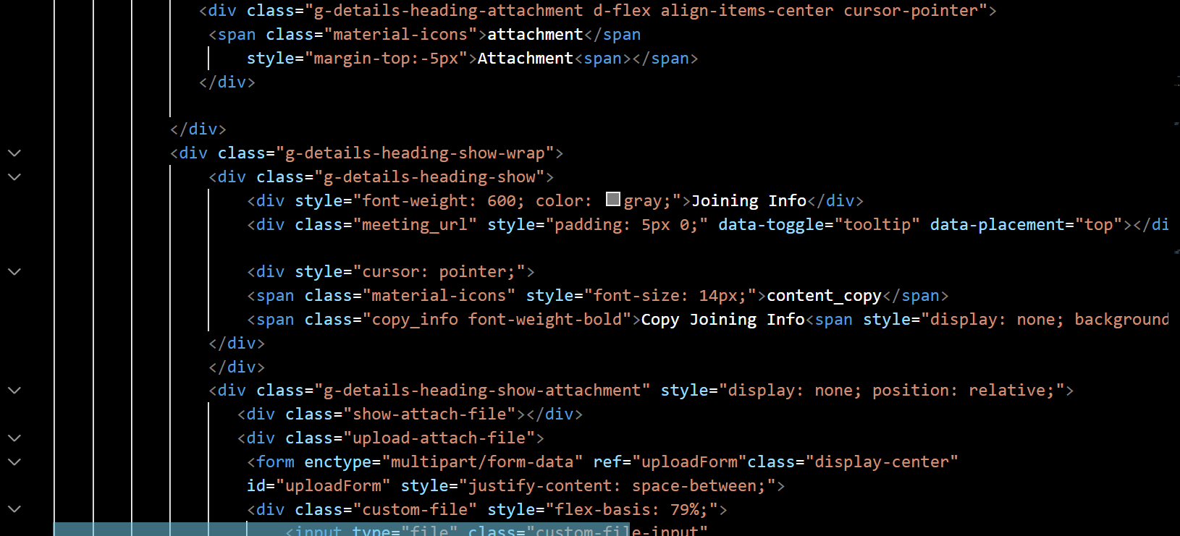

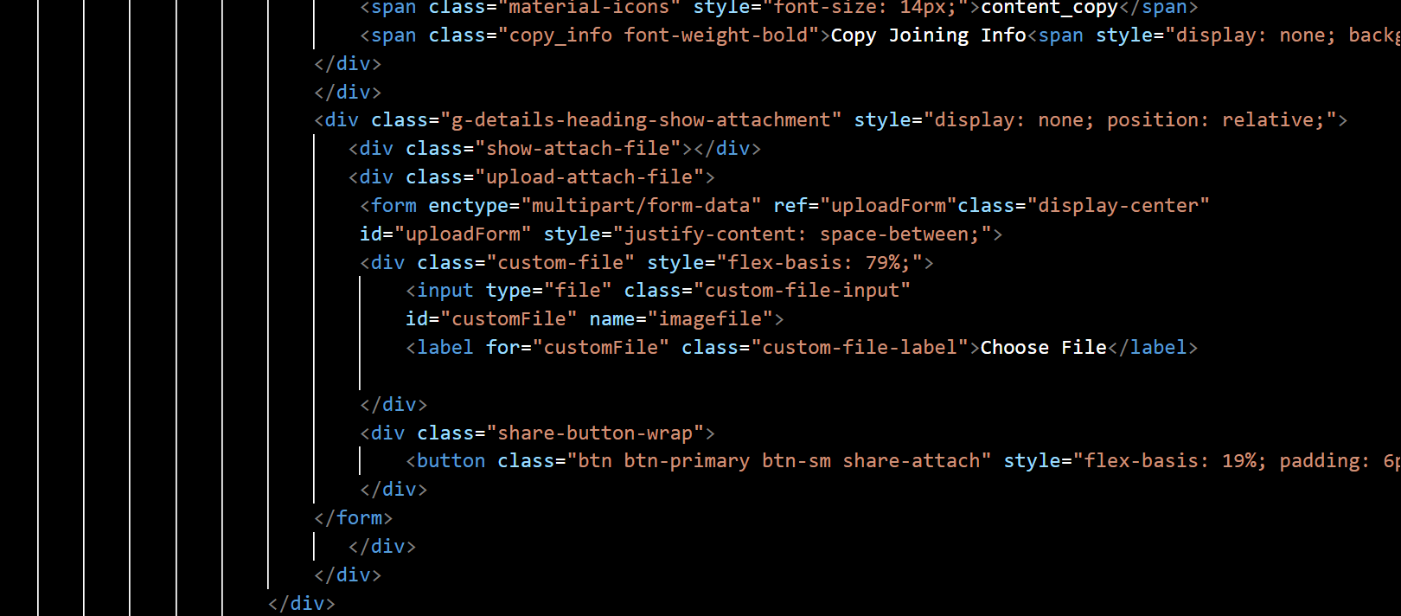

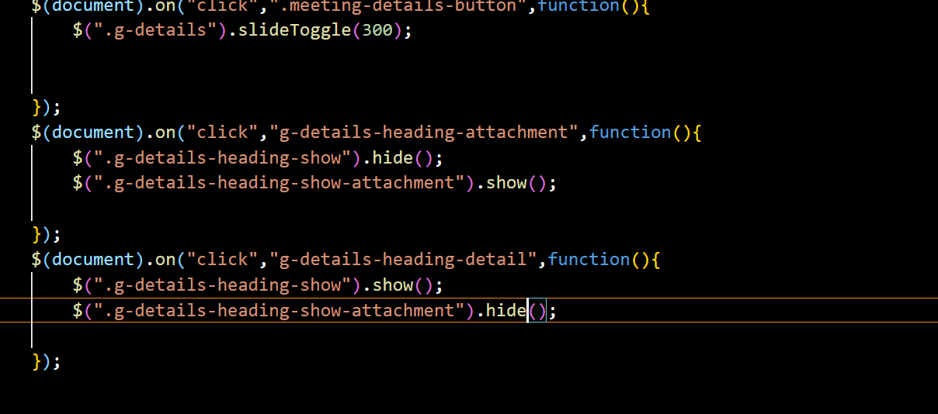

* Now if we click on them green effect should be there

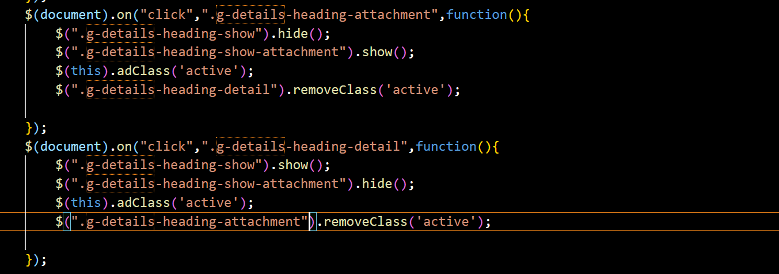

* Now we will be making functionality such that if we click outside g-details class it should be close
* 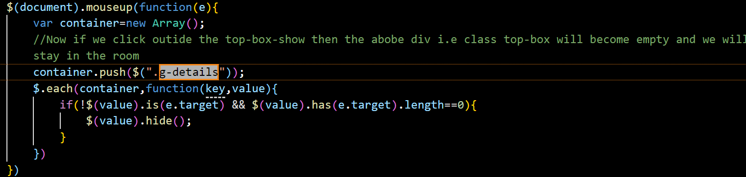
* Now similar functionality we will apply to the chat and participant area
* 